REGISTRATION APPLICATION FORM  DIPLOMA & DEGREE PROGRAMMES |  | 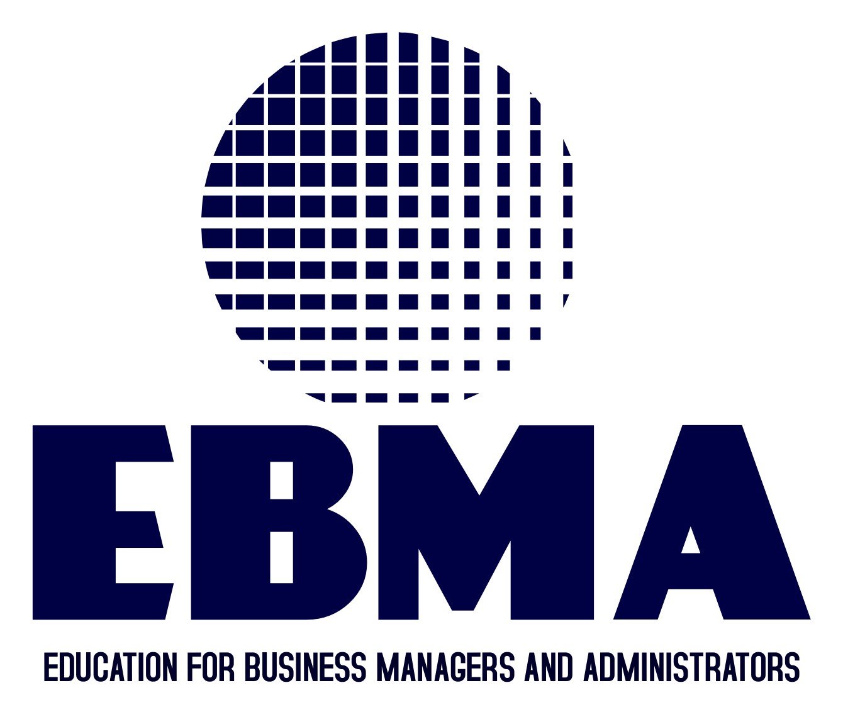

Please complete in typescript or black ink and return to registration@ebma.org.uk

1. PERSONAL DETAILS
Please enter your details as per your passport
  Title (Mr/Miss/Dr etc.)
  First name(s)
  Surname/family name
  Previous surname
  (if applicable)
  Contact address
  Postcode
  Country
  Day time telephone no
  Evening telephone no
  Mobile
  Fax
  Email
  Nationality
  Country of birth
  Country of
  permanent residence
  Date of birth:
  day |  |  |  | month |  |  |  |  | year
  Sex (enter ‘x’) |  |  |  |  | male |  |  | female
  Permanent address (if different from contact)
  Postcode
  Country
  Tel no (including country and area code)
  Fax

2. PROPOSED PROGRAMME OF STUDY AND CENTRE INFORMATION

Qualification Title  e.g. Level 7 Diploma in Executive Management |  | Academic year
Centre Name
(if Known)
Start Date
(Specify Month)

3. EDUCATION
Please give details of your university/college education (i.e. first degree/diploma and higher degree/diploma)
Qualification  (e.g. BA, BD, BSc,  MA, MSc) | Title of programme/  field of study | Name of institution/Awarding body | Country of institution

Professional/other relevant qualifications
Title of qualification | Name of awarding body | Date from/to | Grade/Level | Type of membership (if apt.)

4. LANGUAGE

Is English your first language? □Yes □No
Is/was English the language of instruction for your first degree? □Yes □No

5. EMPLOYMENT DETAILS

Name and address of current employer (where appropriate)  and past employer(s) | Position held | Date from/to

6. REFEREE/S
Please provide at least one current academic or professional reference letter with this application. Reference letter must be on the official letterhead paper where your current employer/supervisor/tutor or other working professional can comment on your communication skills, motivation, academic skills, confidence level or any other relevant information.

1 Name | Position | Contact Official Email Address
Address | Employer/Institution | Contact Telephone Number
Relationship with you

7. FINANCE

Please tell us how you are planning to fund your tuition fees.
 | 1 Your own means |  | 2 Your family
 | 3 Your employer |  | 4 Other (Please specify below)

8. CRIMINAL CONVICTIONS

If you have been convicted of a criminal offence, excluding either a motoring offence for which a fine and/or maximum of three penalty points were imposed or spent sentences, you are required to declare this by indicating yes on your form.

Do you have any criminal convictions? Please tick the appropriate box: | Yes |  | No

9. Disability, dyslexia or long-term medical condition (Tick As appropriate)
- None
- You have a specific learning difficulty(for example dyslexia)
- You are a blind or partially sighted
- You are deaf or have impaired hearing
- You use a wheelchair or have mobility difficulties
- You have mental health difficulties
- You have a disability that cannot be seen, for example, diabetes, epilepsy or a heart condition
- You have two or more of the above

10. Document checklist
Please check that your application is complete and that you have enclosed all the relevant documents or the registration process could be delayed.
- Fully complete the application form with signature
- Previous qualifications as per section 3 (please include certificate and transcript).
- Passport Colour (in Word/jpg/pdf format).
- Passport size picture (.jpg format).
- Any supporting document.

11. DECLARATION

I confirm that the information given on this form is true, complete and accurate and no information requested or other material information has been omitted. I consent to EBMA processing my personal data in accordance with the data protection policy and the provisions of the Data Protection Act. If I do not fully comply with these requirements, the EBMA shall have the right to cancel my application and I shall have no claim against the EBMA.

Signed |  | Date

